scdsds

11 November 2022

**Detailed Design Document**

**IDFC Optimus Savings Account Co-origination journey v0.2**

**Important: The printed copy of this document is not under control.**

Document Revision History

**Optimus Web Application – Savings Account Journey**

|  |  |  |  |  |
| --- | --- | --- | --- | --- |
| **Version** | **Description** | **Author** | **Reviewed By** | **Review Date** |
| 0.1 | Created | Kumar Mahadevan |  |  |
| 0.2 | Added On boarding diagram for API authentication | Kumar Mahadevan |  |  |
| 0.3 | Updated panNumer in aadhar validate api, Added create account api contract | Vivek Wadkar | Kumar Mahadevan | 21/10/2022 |
| 0.4 | Updated API authentication flow | Kumar Mahadevan |  | 11/11/2022 |

Statement of Confidentiality



This document is being submitted to IDFC First Bank by Persistent, with the explicit understanding that the contents would not be divulged to any third party without prior written consent from IDFC. All registered trademarks acknowledged.

Ownership of all Confidential Information, in whatever media it resides, remains with IDFC.

Confidential Information in this document shall not be disclosed outside the IDFC decision makers and shall not be duplicated, used, or disclosed in whole or in part for any purpose.

Contents

1 Overview 6

1.1 Scope of the document 6

1.2 Intended Audience 6

1.3 System Overview 6

2 Low Level System Design 7

2.1 Use case representation 7

2.2 Use case realization 7

2.3 Navigation Flow/UI Implementation 8

2.4 Client-side Validation implementation 9

2.5 Server-side Validation implementation 9

2.6 Component design 9

2.7 API contract design 10

2.8 Configuration settings 10

3 Data Design 11

3.1 Key Schemas/Tables in the Database 11

3.2 Key Design considerations in data design 11

4 Frameworks used 12

4.1 Caching 12

4.2 Exception handling 12

4.3 Design Frameworks 12

5 Performance considerations 13

5.1 Component performance 13

5.2 Database performance 13

6 Unit testing 14

7 References 15

Abbreviations

The below table provides list of abbreviations and specific terms used throughout this document.

|  |  |  |
| --- | --- | --- |
| **Sr. No** | **Abbreviation** | **Description** |
| 1. |  |  |
| 2 |  |  |
| 3 |  |  |
| 4 |  |  |
| 5 |  |  |
| 6 |  |  |
| 7 |  |  |
| 8 |  |  |
| 9 |  |  |

# Overview

## Scope of the document

This document outlines the Low-level design of Use cases for the Co-origination Savings Account journey. It highlights/refers the Use cases in the Co-origination Savings Account journey process and low-level design details of component interactions along with the rationale for the same. This document is reference design document for developers/implementers so that they can develop system with minimal effort

## Intended Audience

* PSL SA development team
* IDFC Architects/ISG
* SFDC development team

## System Overview

Co-Origination journey is a loan journey that offers 2-wheeler & 4-wheeler loans to customers. This loan journey’s UI is being currently developed in SFDC. During the loan journey, based on a customer’s eligibility for other product offers, Savings Account can also be offered to him. While availing the Savings Account offers, the SFDC system interacts with OPTIMUS Savings Account Experience layer API’s – verifyAdhaar, validateAdhaar, createAccount to complete the Savings Account journey. Post account creation, the user will be landed on to the existing React JS UI for completing his VKYC

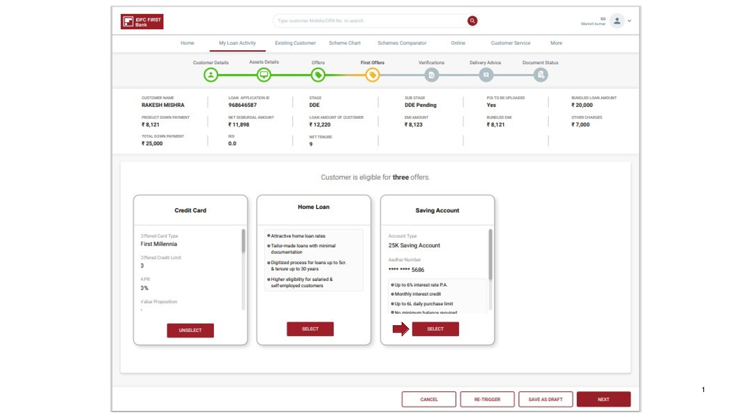

# Low Level System Design

## Use case representation

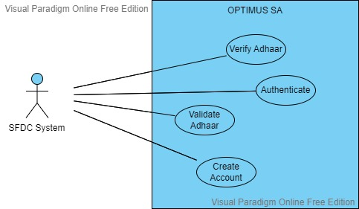

## Use case realization

A). Verify Aadhaar

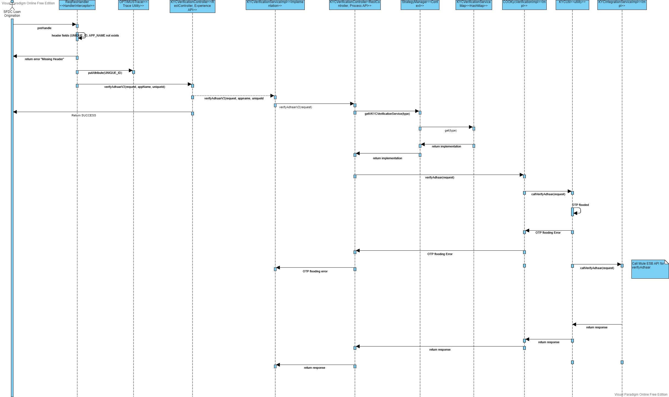

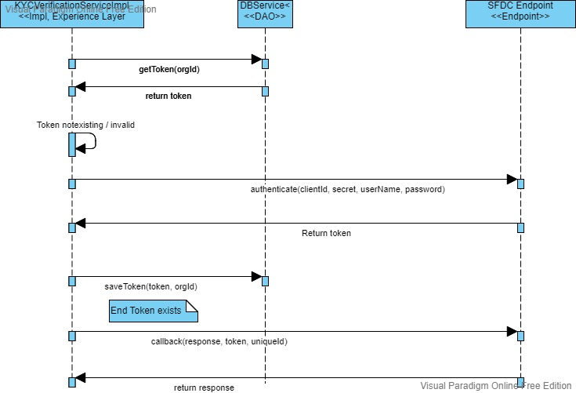

B). API Authentication

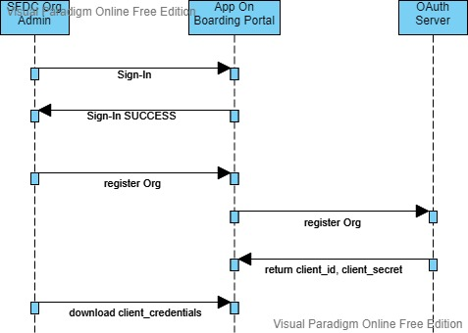

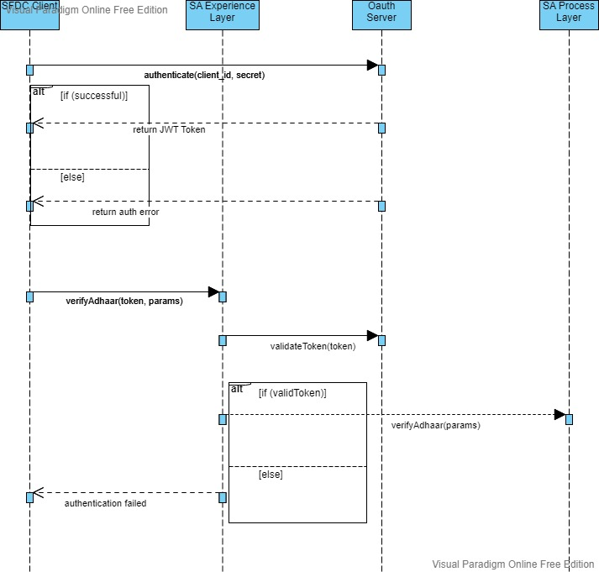

## Navigation Flow/UI Implementation

## Client-side Validation implementation

## Server-side Validation implementation

## Component design

## API contract design

A). Verify Aadhaar

***Service URL(s)***:

|  |  |
| --- | --- |
| **Environment** | **URL** |
| **DEV** | <https://api.dev-opt.idfcfirstbank.com/api/sf-sa/v2/aadhar/verify> |
| **QA** | <https://app.qa-opt.idfcfirstbank.com/api/sf-sa/v2/aadhar/verify> |
| **UAT** | <https://app.uat-opt.idfcfirstbank.com/api/sf-sa/v2/aadhar/verify> |

***Request***:

Method: POST

Header:

|  |  |  |  |
| --- | --- | --- | --- |
| **Key** | **Value** | **Encryption required** | **Description** |
| accessToken | bearer uuFX9KMoNTG4DvchrzUb6sm8jxOmp3V51YAMieKgRDQ.EfzjJRiLSDncmNdbGmj2_vgTKKLu2v4xoZCRCS3zyvQ | No | Bearer JWT token that is returned after authentication |
| orgId | 00D0w0000008ec7 | Yes |  |
| uniqueId | [ Co-relation id ] | Yes | A unique identifier required while performing Async communication to identify the caller |
| appId | COO | Yes | A unique application id for each journey |
| mobileNo | 111111111 | Yes | User’s mobile no |

Request Body:

{

“uid”: “<encrypted Adhaar no>”

}

***Response***:

Success Response*:*

*Sync response*

*{*

*"status": "SUCCESS",*

*"message": "Request submitted.",*

*"responseCd": "00"*

*}*

*Async Response to sf-callback*

{

“status”: “SUCCESS”,

“message”: “Aadhar number verified successfully…”,

“responseCd”: “00”,

“otpTxn”: “2022072512093557987da2”

}

Error Response(s) to sf-callback:

{

“status”: “ERROR”,

“message”: “Please enter a valid 12 digit Aadhaar or 16 digit VID number”,

“responseCd”: “E-149”,

“otpTxn”: null

}

{

“status”: “ERROR”,

“message”: “Sorry, your Aadhaar authentication could not be completed. Please try again after sometime”,

“responseCd”: “GEVERIFYOTP”,

“otpTxn”: null

}

*Validations* – 400 Bad Request with error message

“accessToken”: NOT NULL, message : Access token is missing

“orgId”: NOT NULL, message : OrgId is missing

“uniqueId”: NOT NULL, message : UniqueId is missing

“appId”: NOT NULL, message : AppId is missing

“mobileNo”: NOT NULL, message : Mobile Number is missing

“uid”: NOT NULL, message : Uid is missing

C). Validate Aadhaar

***Service URL(s)***:

|  |  |
| --- | --- |
| **Environment** | **URL** |
| **DEV** | <https://api.dev-opt.idfcfirstbank.com/api/sf-sa/v2/aadhar/>validateOtp |
| **QA** | https://app.qa-opt.idfcfirstbank.com/api/sf-sa/v2/aadhar/validateOtp |
| **UAT** | https://app.uat-opt.idfcfirstbank.com/api/sf-sa/v2/aadhar/validateOtp |

**Request**:

*Method* - POST

*Header* –

|  |  |  |  |
| --- | --- | --- | --- |
| **Key** | **Value** | **Encryption required** | **Description** |
| accessToken | bearer uuFX9KMoNTG4DvchrzUb6sm8jxOmp3V51YAMieKgRDQ.EfzjJRiLSDncmNdbGmj2_vgTKKLu2v4xoZCRCS3zyvQ | No | Bearer JWT token that is returned after authentication |
| orgId | 00D0w0000008ec7 | Yes |  |
| uniqueId | [ Co-relation id ] | Yes | A unique identifier required while performing Async communication to identify the caller |
| appId | COO | Yes | A unique application id for each journey |
| mobileNo | 111111111 | Yes | User’s mobile no |

Request Body:

{

"uid": "NkW+lTdWNBw03hex1fBK+Q==<in encrypted form>”,

"otpTxn": "2022101412571908397d9c",

"otp": "283457"<encrypted>,

"mobileNumber": "7058858123"<encrypted>,

"emailId": "<encrypted email address>",

"panNumber": "NkW+lTdWNBw03hex1fBK+Q==<in encrypted form>",

"cmpgnId": null,

"refferalCode": null,

"utmMedium": null,

"utmSource": null,

"utmId": null,

"utmAction": null,

"utmVariant": null

}

**Response**:

*Sync response:*

*{*

*"status": "SUCCESS",*

*"message": "Request submitted.",*

*"responseCd": "00"*

*}*

*Async Response to sf-callback:*

"photo":< In response this is customer photo form uidai(aadhar details) in base64 encoded.>

"aadharInfo":<In Response this is customer aadhar details in encrypted format>

{

"status": "SUCCESS",

"message": "Aadhar OTP verified successfully...",

"responseCd": "00",

"userId": 3289,

"photo": "",

"aadharInfo": "",

"pincodeServicable": true,

"defaultBranch": {

"branchCode": "42923",

"ifscCode": "IDFB0042923",

"branchName": "SOLAPUR BRANCH",

"isCreditCardServicable": false

},

"lead_Id": "1000384272"

}

*Validations* – 400 Bad Request with error message

“accessToken”: NOT NULL, message : Access token is missing

“orgId”: NOT NULL, message : OrgId is missing

“uniqueId”: NOT NULL, message : UniqueId is missing

“appId”: NOT NULL, message : AppId is missing

“mobileNo”: NOT NULL, message : Mobile Number is missing

“uid”: NOT NULL, message : Uid is missing

"otpTxn": NOT NULL, message : OTP Transaction is missing

"otp": NOT NULL, message : OTP is missing

"mobileNumber": message : Mobile no is missing

D). Create Account

***Service URL(s):***

|  |  |
| --- | --- |
| **Environment** | **URL** |
| **DEV** | <https://api.dev-opt.idfcfirstbank.com/api/sf-sa/v2/account> |
| **QA** | [https://app.qa-opt.idfcfirstbank.com/api/sf-sa/v2/account](https://app.qa-opt.idfcfirstbank.com/api/sf-sa/v2/account%20) |
| **UAT** | https://app.uat-opt.idfcfirstbank.com/api/sf-sa/v2/account |

**Request**:

*Method* - POST

*Header* –

|  |  |  |  |
| --- | --- | --- | --- |
| **Key** | **Value** | **Encryption required** | **Description** |
| accessToken | bearer uuFX9KMoNTG4DvchrzUb6sm8jxOmp3V51YAMieKgRDQ.EfzjJRiLSDncmNdbGmj2_vgTKKLu2v4xoZCRCS3zyvQ | No | Bearer JWT token that is returned after authentication |
| orgId | 00D0w0000008ec7 | Yes |  |
| uniqueId | [ Co-relation id ] | Yes | A unique identifier required while performing Async communication to identify the caller |
| appId | COO | Yes | A unique application id for each journey |
| mobileNo | 111111111 | Yes | User’s mobile no |

*Request Body* –

{

"userId": 3385,

"basicDetails": ""

}

**Note: Same encryption used here to encrypt the basic details. Below are decrypted basic details.**

{

"mobileNumber": "9423572416",

"emailId": "pranithrtha_mahajan@persistent.com",

"panNumber": "BFOPM6732D",

"occupation": {

"id": "3",

"displayText": "Partnership/Company",

"label": "Partnership/Company",

"value": "Partnership/Company",

"sourceOfIncome": "Business"

},

"sourceOfIncome": {

"id": "1",

"displayText": "Business",

"value": "Business",

"label": "Business"

},

"grossAnualIncome": "436456",

"motherFullName": "gerat retey",

"companyDetails": null,

"commAddress": null,

"cardType": "PLATINUM",

"branchDetails": {

"branchCode": "41359",

"ifscCode": "IDFB0041359",

"branchName": "KARVE NAGAR BRANCH",

"isCreditCardServicable": true

}

}

**Response**:

*Sync response:*

*{*

*"status": "SUCCESS",*

*"message": "Request submitted.",*

*"responseCd": "00"*

*}*

*Async Response to sf-callback:*

{

"status": "SUCCESS",

"message": "Account created successfully....",

"responseCd": "00",

"accountDetails": "",

"creditCardDetails": null

}

**Note: Same encryption used here to encrypt the accountDetails. Below are decrypted accountDetails.**

{

"ifscCode": "IDFB0040101",

"accountNumber": "21484594029",

"custRefId": "9903858000",

"preferredBranch": "BKC - NAMAN BRANCH",

"serverTime": "2022-10-19T16:20:49.852096",

"productName": "ONLINE SAVINGS 25K",

"customerName": "Pranita Vinod Mahajan",

"nameOnDebitCard": "PRANITA MAHAJAN",

"vkycEnabled": true,

"ipvEnabled": true,

"commAddress": {

"address1": "FLAT NO.11A DEEP JYOTI AVENUE BEHIND",

"address2": "DILIP BARATE BUNGLOW Pune ",

"address3": "",

"pincode": "411058",

"city": {

"value": "411",

"displayText": "PUNE"

},

"state": {

"value": "60",

"displayText": "MAHARASHTRA"

},

"country": {

"value": "IN",

"displayText": "INDIA"

}

},

"kycCompleted": "FALSE",

"kycCompletedTime": "",

"enachCompleted": false,

"fundingCompleted": false,

"fundingCompletedTime": "",

"fundingAmount": "",

"chequeBookPickUpCompleted": false,

"chequeBookPickUpCompletedTime": "",

"shareHrCompleted": false,

"branchCd": "40101",

"productType": "2000",

"subProductType": "1020",

"resumedAfterLogTime": false,

"vkycAgentStatus": "",

"vkycAgentStatusReason": "",

"vkycCheckerStatus": "",

"vkycAgentComment": "",

"isPaymentFromLandingPg": false

}

## Configuration settings

* This section will capture the details of different settings/configurations being used in system application

# Data Design

## Key Schemas/Tables in the Database

## Key Design considerations in data design

# Frameworks used

## Caching

## Exception handling

## Design Frameworks

# Performance considerations

## Component performance

## Database performance

# Unit testing

* This section will capture the details for list of unit test cases being used for testing a particular component
* Reference of unit test case document can be given in this section

# References

* This section will list down the documents which has been refereed while creating this document